**The Executive Summary for Nigeria's Covid-19 Data Analysis Project**

The following summary report is the result of a data analysis performed on the Coronavirus disease (COVID-19) data of Nigeria, a West-African country. The goal of this data analysis project is to identify insights that can reveal vital trends and help in improving operational response preparedness.

1. **Data overview and methods**

The dataset in CSV format was collected and imported into python as data frames. From the global Johns Hopkins data, the data specifically for Nigeria containing one row and 760 columns were extracted for further analysis. The data from the Nigeria Centre for Diseases Control (NCDC) contains 37 rows for each state and five columns which were renamed as States, Confirmed, Admitted, Discharged, and Deaths. The data type in each column was checked and was converted to standard forms suitable for the intended analysis, e.g., date values in object format were converted to DateTime data type. The data was then explored to identify trends and generate useful insights. Finally, various visualisations were developed in the form of figures to enable an in-depth understanding of the dataset.

1. **Data analysis and results**

The NCDC data analysis revealed that Lagos, with 98693 confirmed cases, has the highest number of cases among the top 10 states in terms of confirmed covid cases by laboratory test and discharged cases, as shown in Figure 1 and Figure 2. Figure 3 presents a pie chart of the top ten states with death cases, with Kaduna having 88 deaths as the lowest among the ten states while Lagos with 769 deaths is the highest.

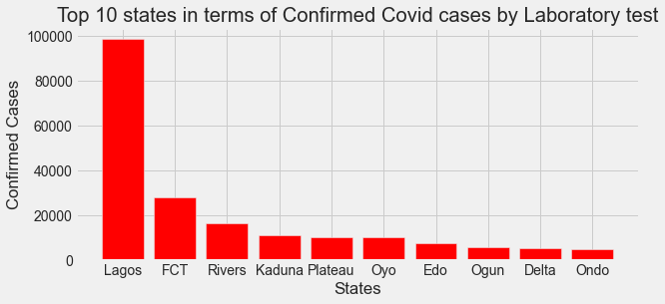

Figure 1. Top 10 states in terms of Confirmed Covid cases

Among the 37 states, Kogi state has the lowest number of confirmed COVID-19 cases and deaths, with five confirmed cases and two deaths recorded.

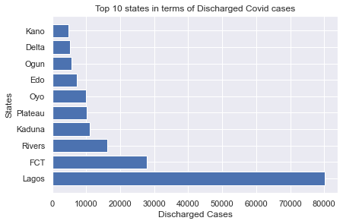

Figure 2. Top 10 states in terms of Discharged Covid cases

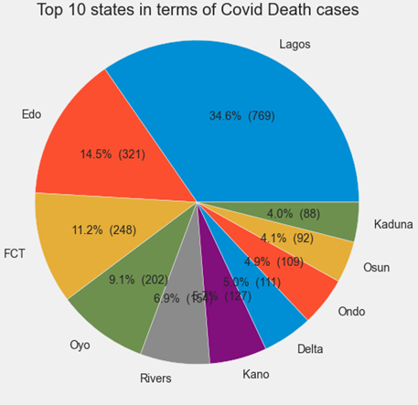

Figure 3. Top 10 states in terms of Covid Death cases

The data specifically for Nigeria from the Johns Hopkins data from 2020 to 2022 shows quite an interesting trend, as shown in the line plot of Figure 4. There was a sudden drop to zero in the number of recovered cases from August 05, 2021, while the number of confirmed cases kept increasing. This may signify non-tracking of recovered cases or may be due to poor data reporting.

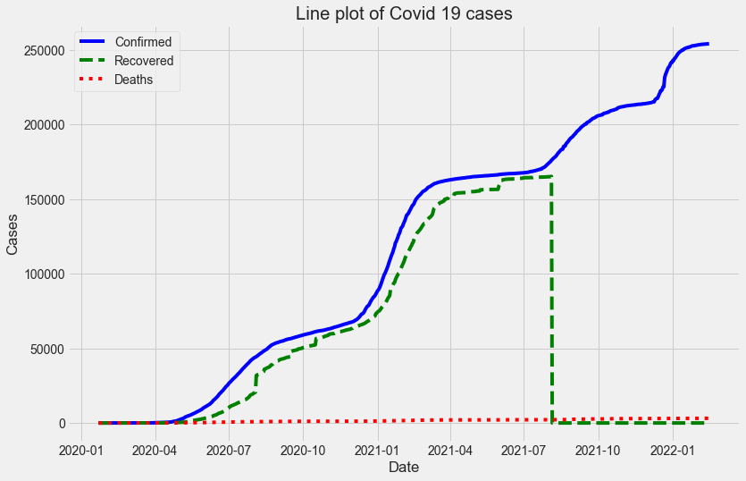

Figure 4. Line plot of Covid 19 cases for Nigeria

The highest number of daily infections occurred on 2021-12-22, with 6158 new cases, as illustrated in Figure 5.

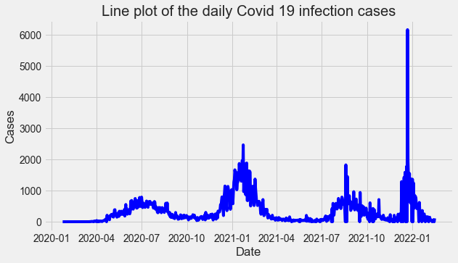

Figure 5. Line plot of the daily Covid 19 infection cases in Nigeria

Regarding the economic impact of COVID-19, the quarterly bar plots in Figure 6 shows that there is a decrease in the real GDP for Q2 2020 as compared with Q2 of previous years as a result of the emergence of COVID-19. Likewise, for Q3 2020, there is a decrease when compared with Q3 2019.

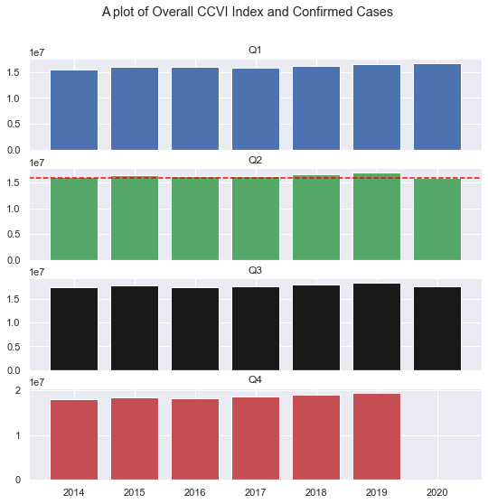

Figure 6. A comparative quarterly plot of GDP

The analysis of the budget data shows that Lagos, with the second-highest percentage change in the budget, had the highest lab-confirmed covid 19 cases. This is most likely due to the presence of a very active international airport in Lagos. The line plot of the initial state budget and the revised budget after COVID-19 is shown in Figure 7.

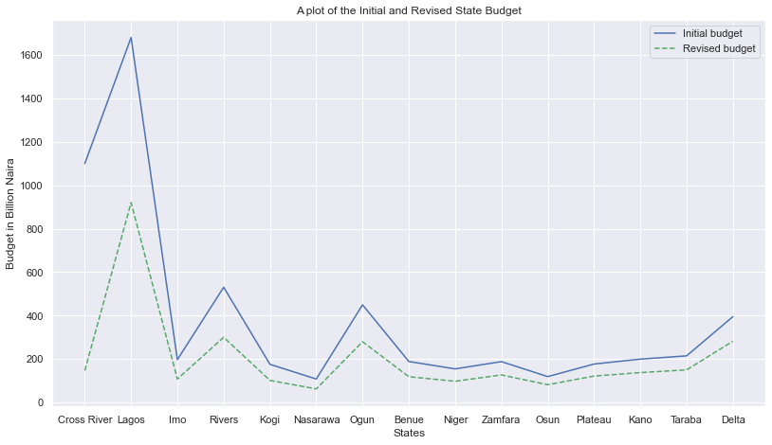

Figure 7. A plot of the Initial and Revised State Budget

The computation of the mean of some of the Nigeria Community Vulnerability Index (CCVI) data variables in Table 1 shows that the North East has the highest average CCVI Index of 0.8833 and Health System Index Score 0.7333, which is indicative of poor health facilities. South East has the highest Acute IHR score of 1.098, which means that a higher percentage of people who got infected there are expected to require acute care. The slope of the regression plot in Figure 8 shows that the number of confirmed cases increased with population density.

Table 1. The aggregation table of the sum and mean of CCVI variables

|  |  |  |  |  |  |  |  |  |  |  |
| --- | --- | --- | --- | --- | --- | --- | --- | --- | --- | --- |
|  | **Population** | | **Overall CCVI Index** | | **Health System** | | **Socio-Economic** | | **Acute IHR** | |
| **Region** | **sum** | **mean** | **sum** | **mean** | **sum** | **mean** | **sum** | **mean** | **sum** | **mean** |
| **North Central** | 33544000 | 4.792000e+06 | 2.3 | 0.328571 | 2.9 | 0.414286 | 3.7 | 0.528571 | 6.12 | 0.874286 |
| **North East** | 29395000 | 4.899167e+06 | 5.3 | 0.883333 | 4.4 | 0.733333 | 4.6 | 0.766667 | 5.24 | 0.873333 |
| **North West** | 54655000 | 7.807857e+06 | 5.5 | 0.785714 | 4.5 | 0.642857 | 6.1 | 0.871429 | 6.11 | 0.872857 |
| **South East** | 27152000 | 5.430400e+06 | 2.1 | 0.420000 | 2.0 | 0.400000 | 1.5 | 0.300000 | 5.49 | 1.098000 |
| **South South** | 28841000 | 4.806833e+06 | 2.5 | 0.416667 | 2.8 | 0.466667 | 1.9 | 0.316667 | 6.15 | 1.025000 |
| **South West** | 42637000 | 7.106167e+06 | 0.9 | 0.150000 | 2.0 | 0.333333 | 0.8 | 0.133333 | 6.19 | 1.031667 |

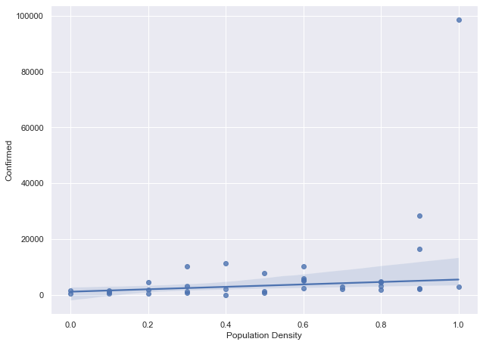

Figure 8. A plot of the Initial and Revised State Budget

1. **Conclusions**

The goal of this data analysis project to identify insights that can reveal vital trends has been achieved. The regression analysis in this study shows that the number of confirmed COVID-19 cases increased with population density. Also, the advent of COVID-19 triggered a decrease in the Real GDP of Nigeria in the year 2020. The highest number of daily infections occurred on 2021-12-22 with 6158 new cases, and also the number of confirmed COVID-19 cases increased with population density. Machine learning techniques can be incorporated in future works.

1. **References**
2. Nigeria Centre for Diseases Control (NCDC) data link: <https://covid19.ncdc.gov.ng/>
3. Global Daily Confirmed Cases - https://github.com/CSSEGISandData/COVID-19/blob/master/csse_covid_19_data/csse_covid_19_time_series/time_series_covid19_confirmed_global.csv
4. Global Daily Recovered Cases - https://github.com/CSSEGISandData/COVID-19/blob/master/csse_covid_19_data/csse_covid_19_time_series/time_series_covid19_recovered_global.csv
5. Global Daily Death Cases - https://github.com/CSSEGISandData/COVID-19/blob/master/csse_covid_19_data/csse_covid_19_time_series/time_series_covid19_deaths_global.csv

**Report written and submitted by:**

Adekitan A. I.